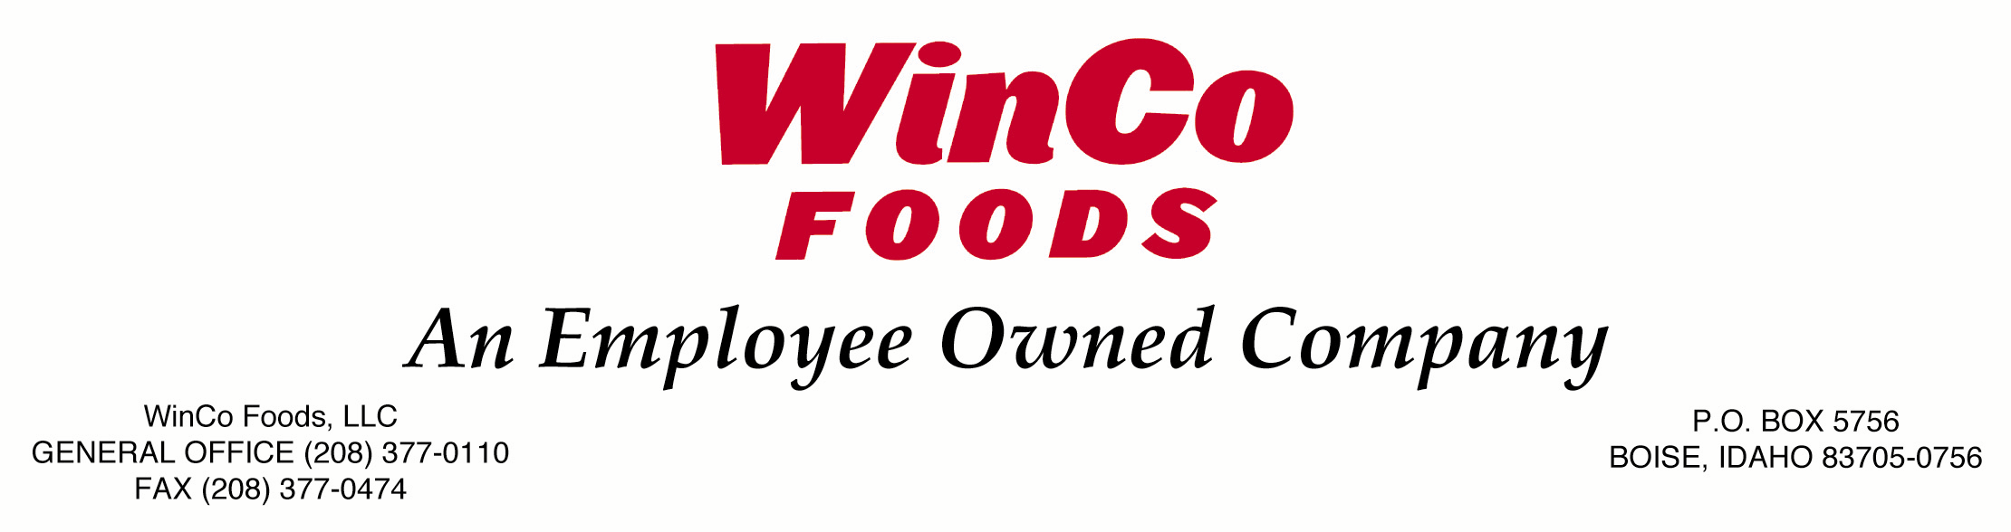

Job Title: Vice President, Bulk Food Operations Date: 8/13

Job Summary
This position is accountable for the procurement, management, costing, distribution, and integrity of all Bulk Foods department items; overseeing and directing all aspects of bulk product sales development and procurement for WinCo Foods.

Typical Duties and Responsibilities:
- Provide leadership in Bulk Foods quality assurance policy and procedure development and implementation in compliance with Federal, State and local regulatory requirements, through interaction with corporate, retail store, and warehousing/transportation departments. Establish goals, monitor progress and achievements.
- Develop innovative cost efficient methods for selecting, ordering and improving purchasing bulk throughout retail, warehouse and distribution systems.
- Provide leadership and supervision to bulk department personnel. Apply continuous improvement processes to enhance work flow, improve job skills, and individual knowledge of bulk to achieve company objectives.
- Analyze and monitor sales records, trends and economic conditions to anticipate customer buying patterns and determine what the company will sell and how much inventory is needed.
- Set weekly ad items, select companywide promotions and oversee division pricing.
- Control and maintain targeted level of labor costs, gross margins (store level and distribution centers) capital expenditures and sales.
- Plan and organize departmental meetings using effective public speaking skills.
- Strategic business forecasting, identify competitive advantages, changes in technology trends, changes in markets to meet the customer demand and company goals.
- Meet with vendors and suppliers to negotiate cost and select new items.
- Lead division supervisors and coordinate with buyers to provide leadership, coaching and set goals.
- Develop and manage the training for the Bulk Foods Manager in Training (MIT) program.
- Performs other duties as needed.

Requirements
Education:
- Bachelor’s Degree or equivalent in Wholesale Bulk Foods Operations, Business Administration, or closely related field OR equivalent education, training and/or experience demonstrating considerable knowledge of wholesale Bulk Foods operations.

Experience:
- 3 years experience establishing and implementing training programs for retail operations.
- In a role as Divisional Supervisor, Director, or Vice President of Bulk Foods or similar Operations for a chain of 50 stores or more. OR comparable experience demonstrating knowledge and experience of overall store and department management.
- 3 years experience applying knowledge of food safety, recall procedures and sanitation.
- 3 years experience verifying compliance with FDA Food Code, Good Manufacturing Practices (GMP) and other requirements including conducting visual inspections and creating reports to address issues, obtain and maintain all necessary licensing /certification.
- Demonstrating strong working knowledge of Microsoft Office (Excel, Word, Outlook, etc.) software.

Ability to:
- Travel up to 50% of the time.
- Be available to respond to calls on urgent matters involving food safety including after business hours, on weekends and holidays.
- Write and speak clearly and succinctly in a variety of communication settings.

Additional Requirements:
- Acceptable Department of Motor Vehicles driving record

Preferred Education, Experience and/or Credentials:
- 5 years’ experience working in retail bulk foods operations or related area.
- Managing overall store operations.
- Strong knowledge of supply chain management.
- Strong business acumen.

The above statements are intended to describe the general nature of work performed by the employees assigned to this job. All employees must comply with company policies and applicable laws. The responsibilities, duties, and qualifications required of personnel may vary.

